COS30015 IT Security
You will need:
CySCA2014InABox (VM)
Kali (VM)
RedHat Linux (VM)
Windows XP Control (VM)
A computer with internet access

Lab 8 (week 9)

In this lab you will experiment with authentication,
encryption and experiment with a one-time pad.

1. Start Virtual Machine Launcher and launch the CYSCA2014InABox with local network image.
Launch Kali Linux with local network

On Kali, log in as root:
Other…
root
toor

start Wireshark
Applications > Internet > Wireshark
Interface List
eth0
Start
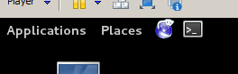
2. On Kali open Telnet:
Open a console
type in
telnet 192.168.100.210 12345 (Enter)

Log in as
student (any password)
The server will kick you out.

3. Check the Wireshark output:

Enlarge the top window
Click on a TCP packet
yes window. The payload of each packet will be at the end.
Use the arrow key (down arrow) to scroll through the packets.
When you see the prompt: Enter your password:
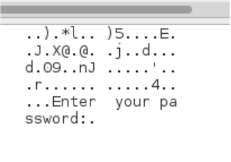
start paying attention. The last bytes (characters) of a subsequent packet will contain the password.

Did you find the password?
Yes…

4. Let’s try this again using an SSH client instead of Telnet.
In the console window, type
ssh 192.168.100.210 12345

Read the SSH security alert.
What is the key fingerprint?

Click Yes

What has the server done with the ECDSA key?

It has been added to the lists of hosts

Enter a password (student) or repeat the ssh log in attempt (arrow-key up to get the old command) if the log-in session has timed out.
You only get one prompt to check the key – if you cache it, your client trusts that server forever.

Are you prompted to examine the key?
No

5. On the host PC, search the internet for a way of removing the key from your Kali vm. What is the command?
ssh-keygen -R hostname

6. Type in a password (something you will recognise later)

Examine the Wireshark packet capture. Look for the first line identified as SSHv2. This contains the beginning of an exchange of encryption capabilities supported by the server and the client.
What versions of SSH is running on the server and client?
Server: OpenSSH5.9
Client: Open SSH6.0

7. Check the next two SSHv2 packets – these exchange the lists of supported encryption suites (Key Exchange Init)

Observe the next SSHv2 packet. From the top window, what kind of key exchange is being set up?
Diffie-Hellman key exchange

Move to the next SSHv2 packet (marked Server: new keys)
In the middle window, expand the SSH field and note the details of the encryption. What kind of encryption will be used?
AES 128-ctr

What kind of MAC (message authentication code) will be used?
HMAC-md5

From now on the message will be sent in encrypted form with each packet containing a MAC to allow the receiver to check for tampering.

While observing the bottom window, scroll through these looking for any recognisable text. Is there any?
No. Everything is encrypted

8. Review your answers to the above questions 4, 5, 6.
and read how SSH connections are made.
What is the problem with this scheme?
Client has to have a cached copy of the server
certificate.

9. Try the capture of plain text and encrypted packets for web page logins.
In the Kali virtual machine, open the browser and surf to
http://192.168.100.210/login.php
Log in as
Warren@kali.org (user)
Eclipse (passwd)
The web site will not let you in.
In Wireshark, monitor the connection sequence (described here: http://www.eventhelix.com/RealtimeMantra/Networking/SSL.pdf). Find and click on the packet which has POST /login.php in the Info section. Scroll to the end of the packet payload to see the user name and password.
What are the username and password (from Wireshark)?
Note that all packets nearby contain the session ID in the payload.
Warren@kali.org, Eclipse

Note that CySCA2014InABox does not have an https server running.
If (hypothetically) you repeated the login process, using
https://192.168.100.210/login.php and observed the SSLv3 packets in Wireshark – You would no-longer be able to identify POST and GET packets as all traffic would now be encrypted.

Note that there is no Diffie-Hellman exchange in SSL. SSLv3 (TLSv1) uses certificates.

10. SSL and SSH protocols include a step where the client and server advise each other of the security protocols they support.
- Client Hello (incl. list of protocols supported)
- Server Hello (selects best protocol)

In some systems, a channel downgrade attack can be done in a MITM by responding to the Client Hello with a Server Hello packet nominating SSL without encryption, or an inferior version of SSL.

11. On the host PC, follow these links and read about it.
https://en.wikipedia.org/wiki/POODLE
https://f0rki.at/slides/f0rki-downgrade-attacks-by-example-bsidesvienna2012.pdf

Public / Private key Crypto
12. Go to
http://www.cs.pitt.edu/~kirk/cs1501/notes/rsademo/
and read the page.
At the bottom of the page are links to three Java-script powered applications which:
a. Generate asymmetric key pairs for PGP.
b. Encrypt a character using one key.
c. Decrypt a character using the other key.

Use the applications to:
Generate keys for a message (use 5 and 7)
encode a four-letter word (eg. 'aced').
decode the encrypted numbers to retrieve the word.
Note: do one letter at a time. Refresh the browser (F5) if it doesn't recalculate.

P = __5___
Q = __7____
D (decrypt) = ________________________
E (encrypt)= __________________________
N (shared key)= ________________________
PHI = _________________
Original word: _______
Encoded message: _______
Decoded message: ____________

One-time pads
13. On Blackboard, download the OTP.zip file to your desktop PC. A One-Time Pad is an authentication system which defeats packet sniffing and keyloggers (replay attacks).
Unzip and run the program (otp4.exe)
- Type 1 to generate a pad.
- Type in the first 6 digits of your student number (your user name)
- Take a screen shot of the numbers displayed. Paste it into a Word doc or image file. This is your one-time pad.
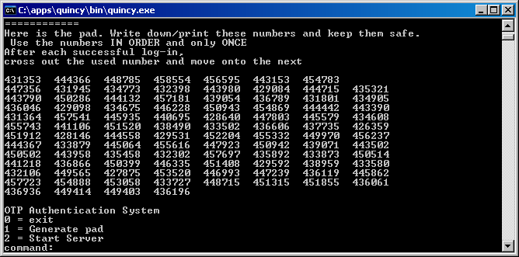

- Type 2 to start the authentication server.
- Type in your user name (number) and passcode (the first number on the pad). It will work only once.
- Log out (exit) and try logging in again. This time, you must use the second number.
- Try shutting down the server (Ctrl + C) - it stores a hash of your most recently used passcode each time you log in successfully.
- Run the program again. Start the server. It will pick up where it left off.
Not the Kioptrix VM
- If you want, look at the source code to see how it works.

14. E-mail sniffing

- Start VMWARE and load in the Red Hat Linux with local network image.
- Download and start XP-Control image.

- On RHLinux box login as
user: root
pass: security
- Start up the DNS server:
service named start

- Check to see if all the services are running, type
service named status
service sendmail status
service xinetd status
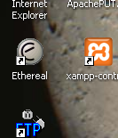

- On XP Control start Ethereal (an old version of Wireshark), start a capture:
Select Capture options
Change the adapter to:
VMWare Accelerated AMD PCNet …
Under Display Options, check the Update List… and Hide … check boxes
Click Start
- Minimise Wireshark and open Email (Outlook Express) from the Start menu
- Configure Outlook:
Type Hacker
Email Address : hacker@server.com
Using POP3 server:
POP3 server is : mail.server.com
SMTP server is : mail.server.com
Account name is : hacker
Password is : warezwarez
- Compose a new email addressed to hacker@server.com (so you can pickup both the send and receive packets in wireshark). Enter “Plain Text Email” as the subject and “Have you encrypted your emails?” as the message body. Click Send
- Click send /receive in outlook on the XP Control to send the email. Your account (hacker) will receive some e-mails from server.com (in the Inbox).
- Once sent, look at the Ethereal output:
Look at the SMTP exchanges.
No authentication
Does the SMTP server require authentication?

Look through the POP packets to find the email.
Find the USER and PASS packets.
Yes – user name and
password

Does the POP server require authentication?

What soty of encryption is being used?
Can you read the message?
None-all in plain text.
Yes

If you inspect the packet, you will be able to find the message you sent in plain text.
- In your inbox, reply to your e-mail and attach a picture. There are some in My Documents/My Pictures (on the XP Control desktop). Click send to send the email.
- Look in the Ethereal output you should be able to see the picture in the output. Scroll down to the last set of SMTP packets, right-click on one and click Follow TCP stream. You will see the base-64-encoded jpeg image.
- Click Save As… and save the contents in a text file on the XP Control desktop.
- Edit the file and delete everything except the base64-encoded image (from the /9 to the /Z if you sent the image below). Save the file.
- Drag the file (slowly) to the desktop of the host PC. Once there, find an on-line BASE64 decoder (try Googling “Base64 decode to file”) and use it to recover the image.


15. Shut down all guest OSs, close VMWare, the browser, etc. and log out.

End of Lab

